COMPUTER ARCHITECTURE

VENKATESH

192011497L

1. 8-BIT ADDITION

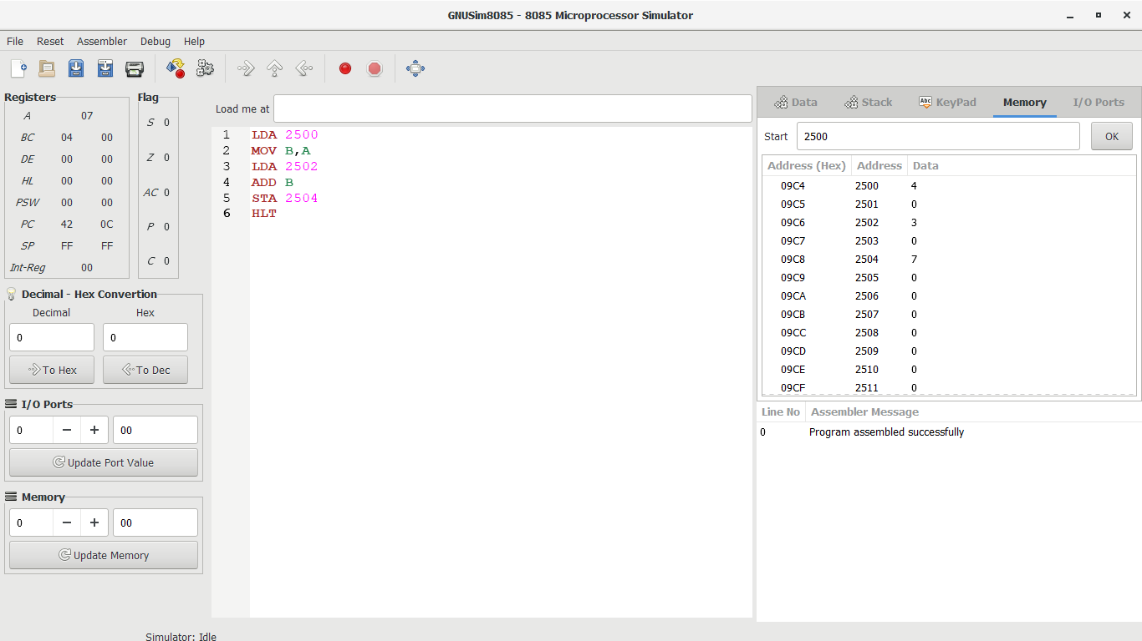

1. 8-BIT SUBTRACTION

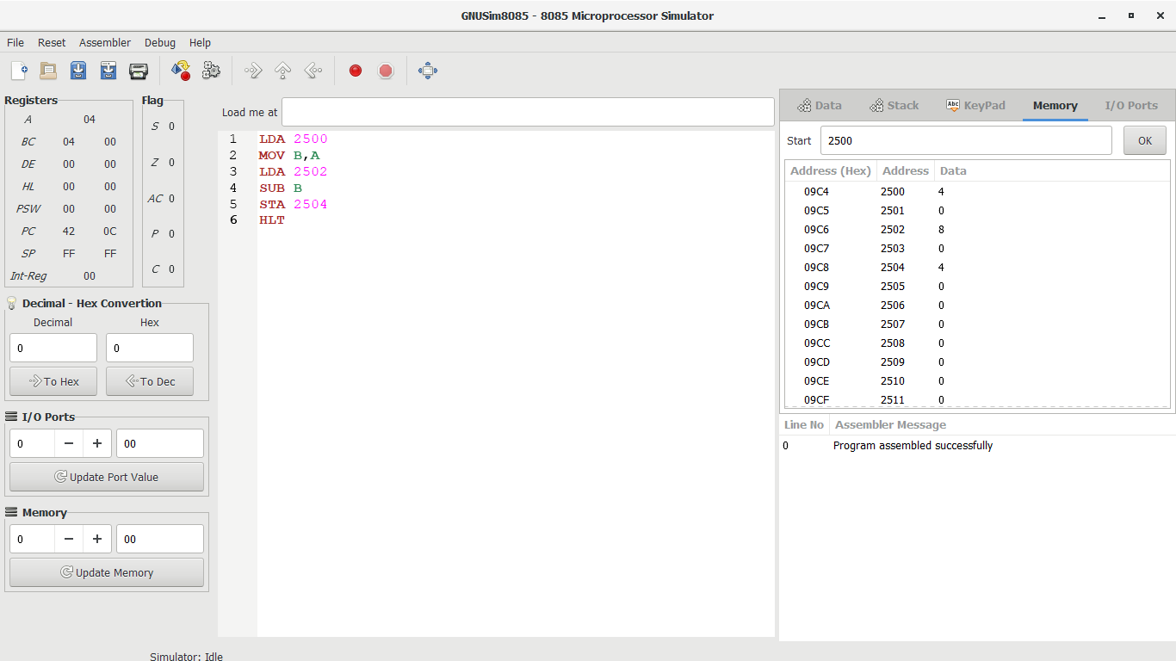

1. 16-BIT ADDITION

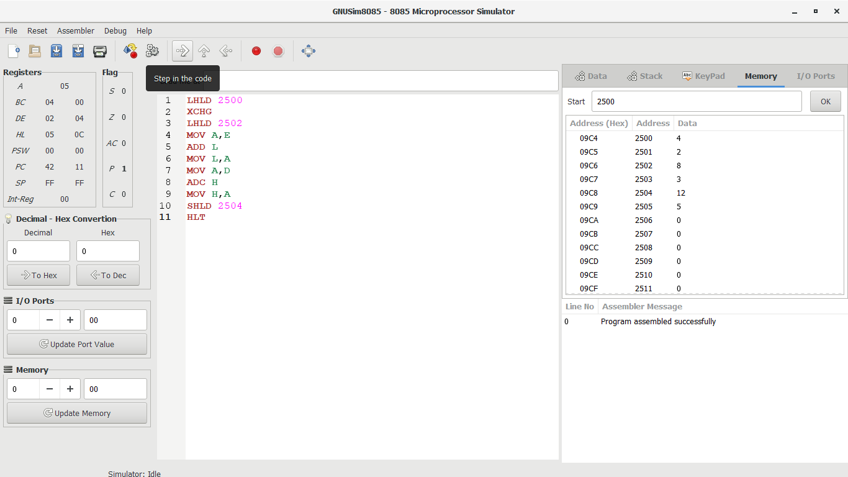

1. 16-BIT SUBTRACTION

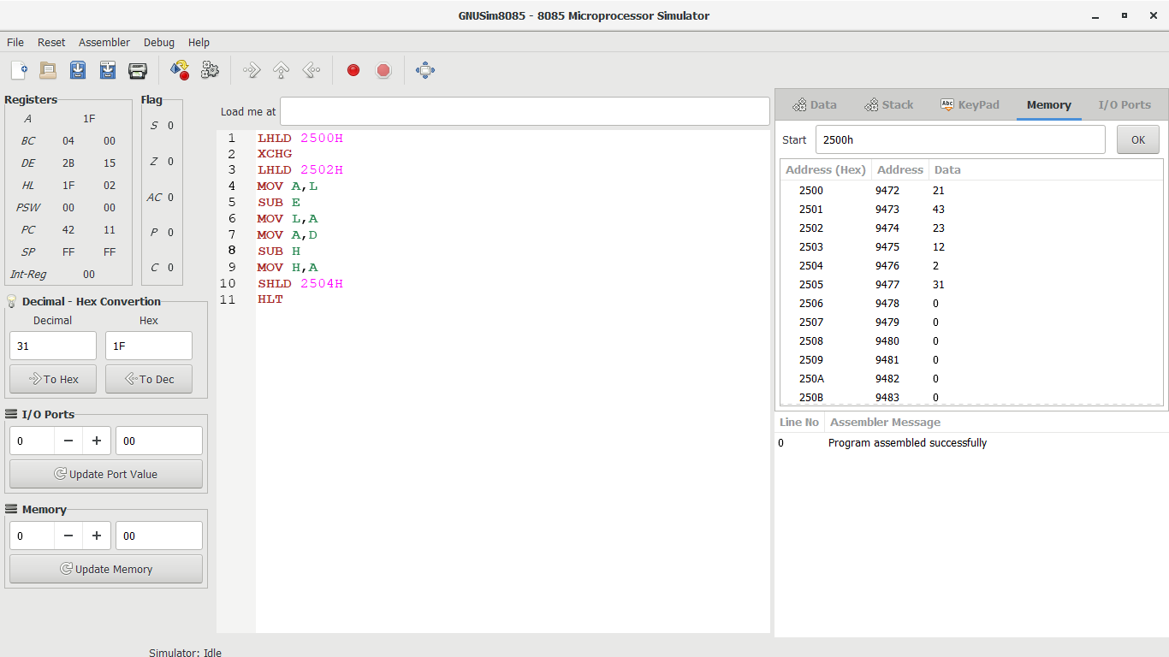

1. 8-BIT DIVISION

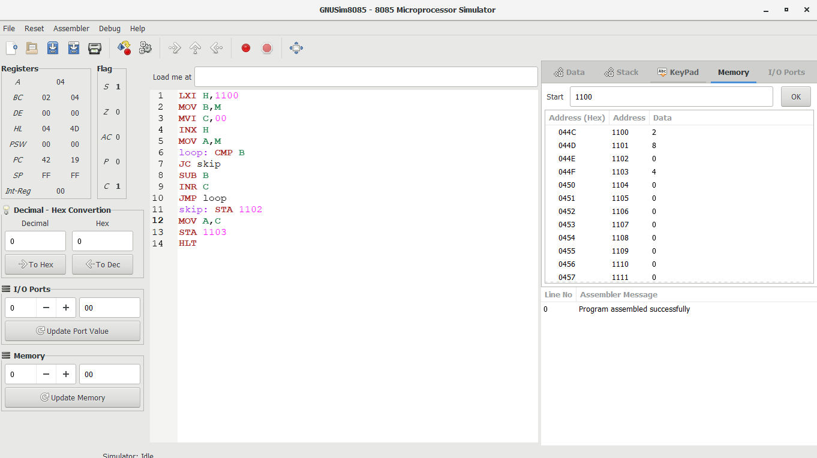

1. 8-BIT MULTIPLICATION

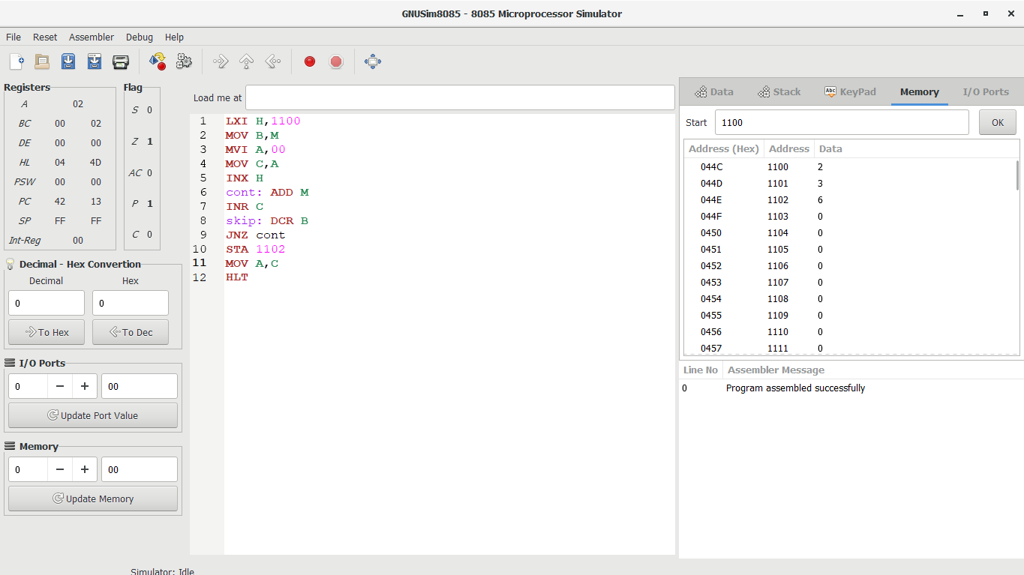

1. SWAPPING TWO NUMBERS

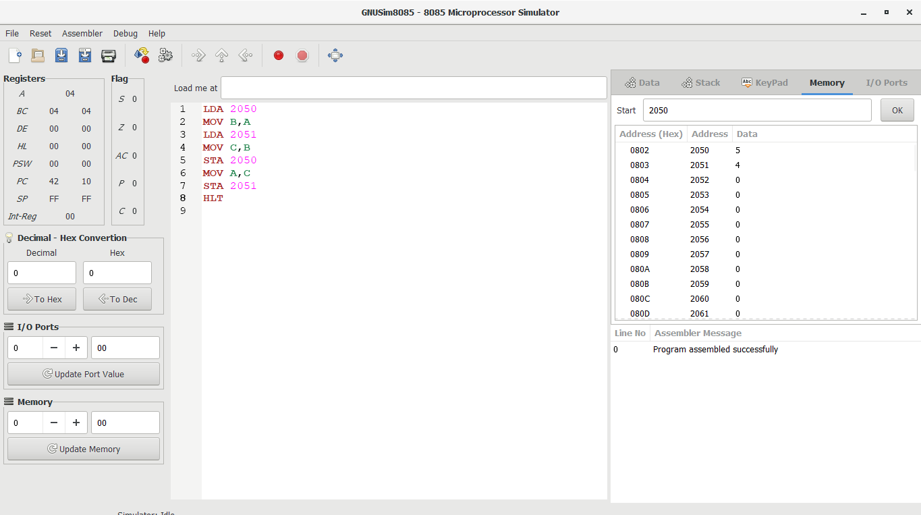

1. LARGEST NUMBER AMONG 2 NUMBERS

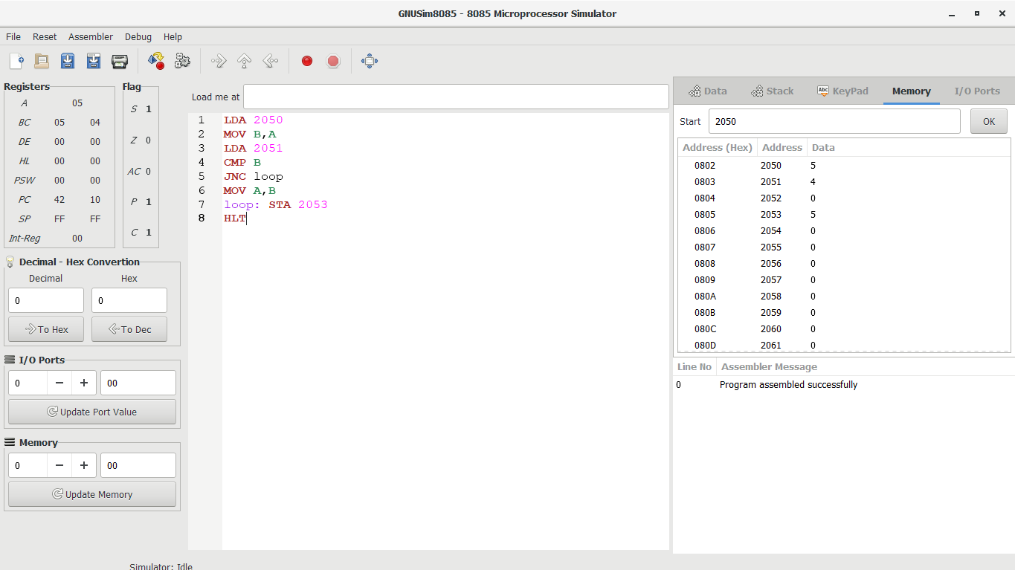

1. SMALLEST NUMBER AMONG 2 NUMBERS

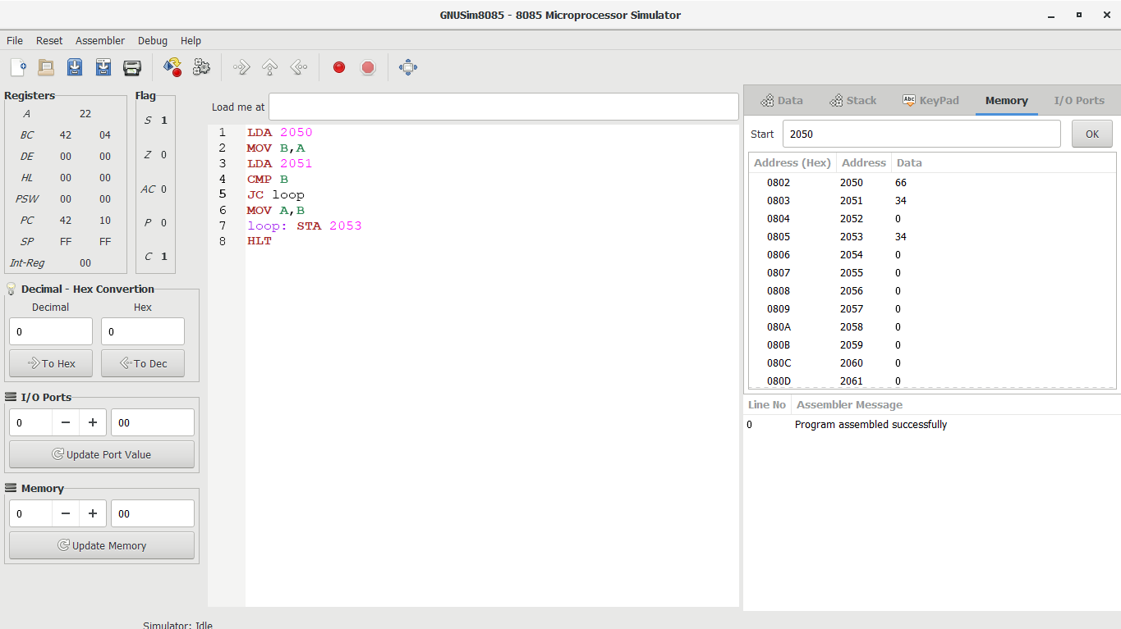

1. FACTORIAL OF A NUMBER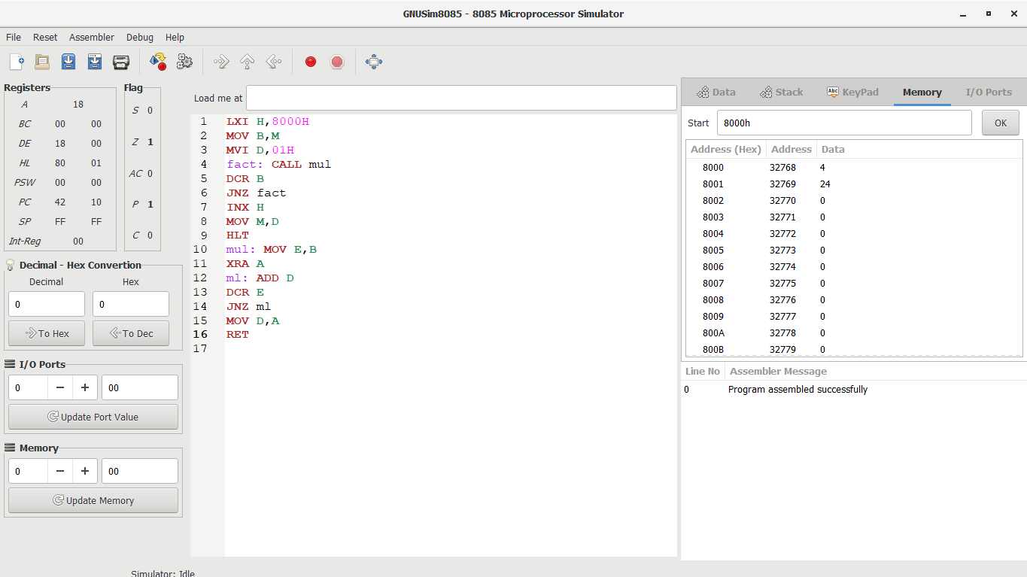
2. 1’S AND 2’COMPLEMENT

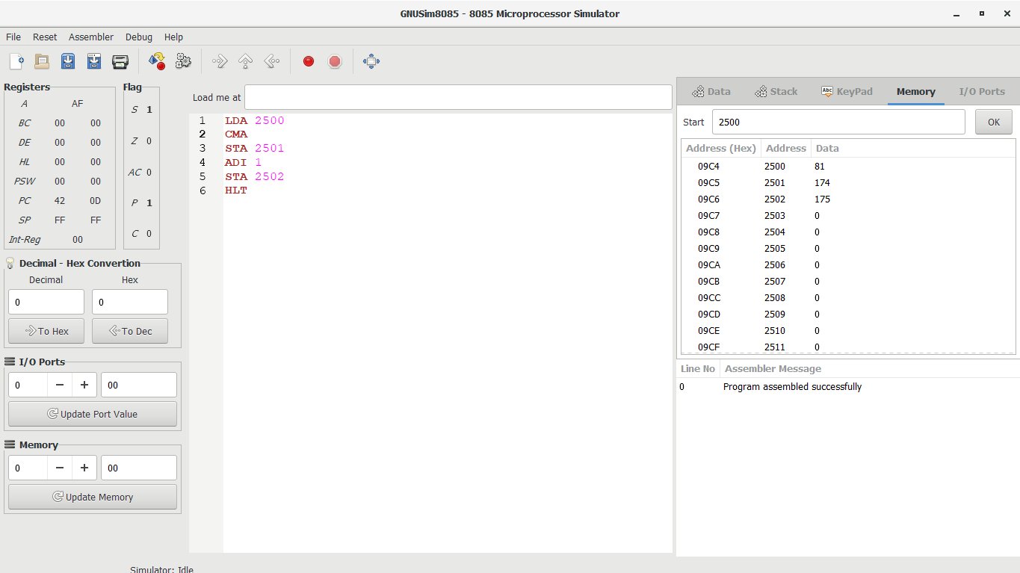

1. HALF ADDER

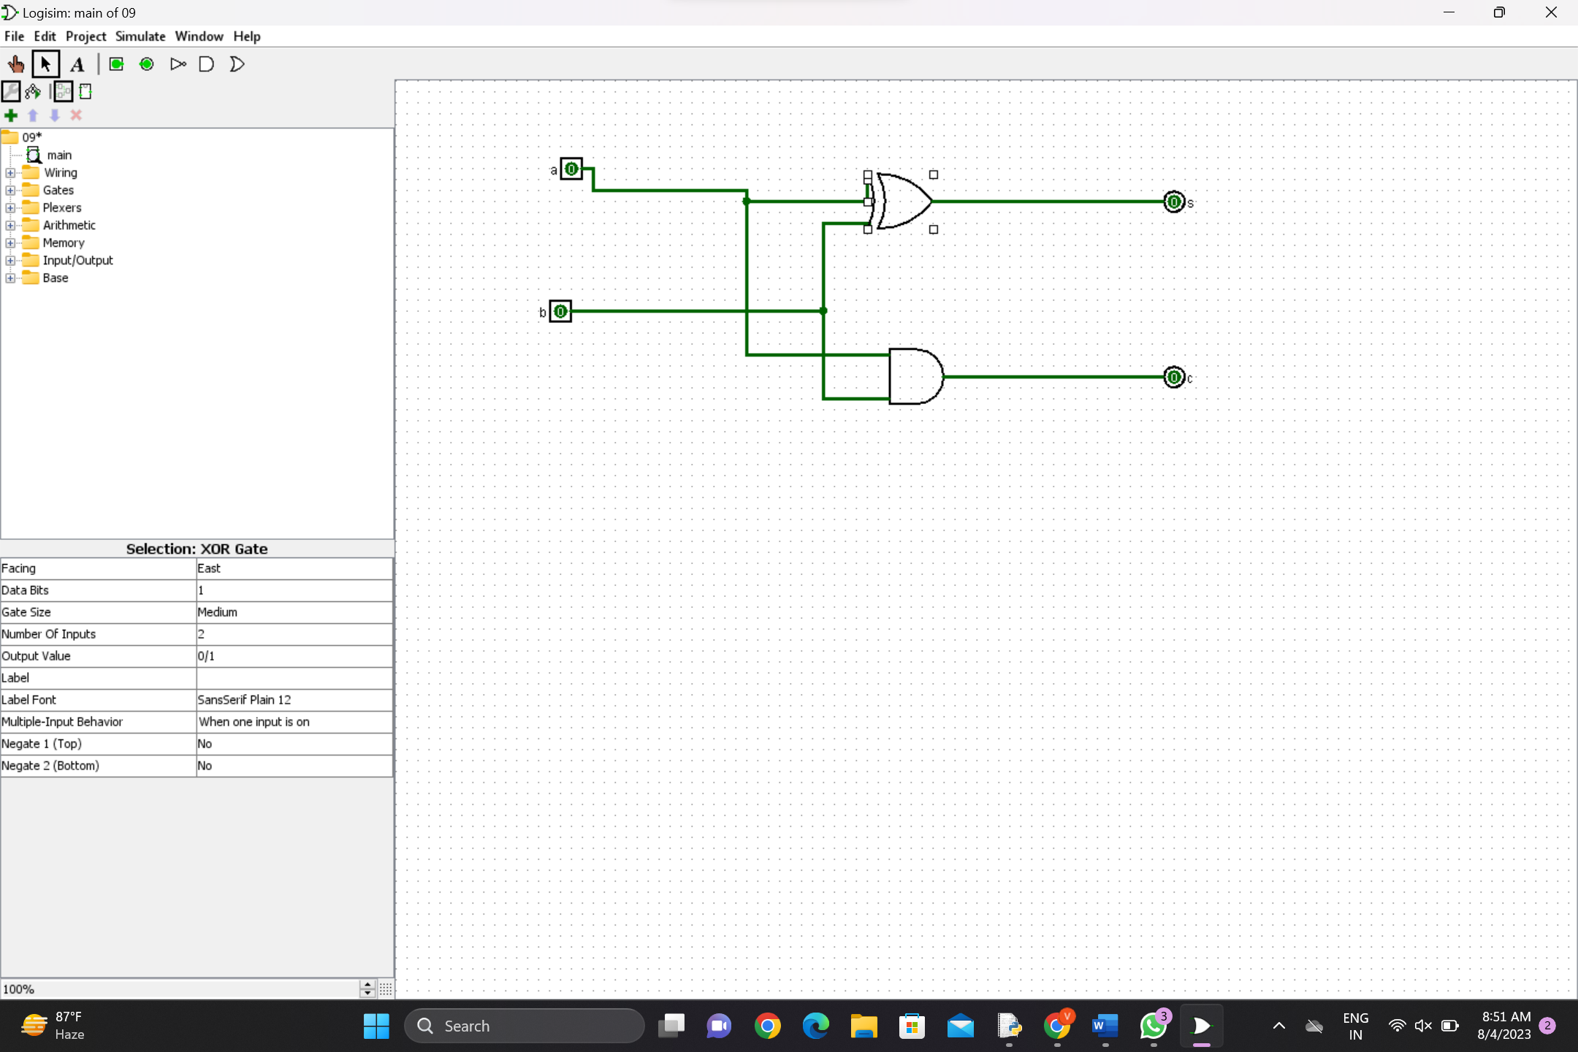

1. HALF ADDER USING NAND GATES IN LOGISM

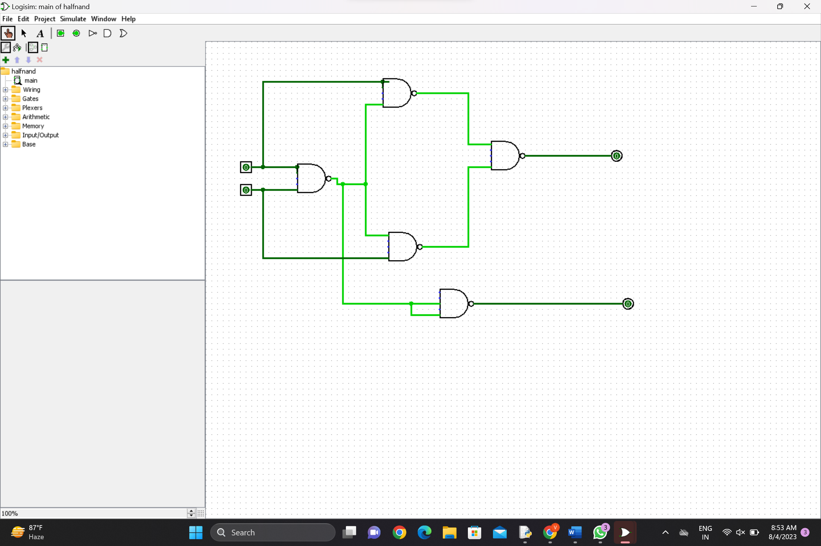

1. FULL ADDER IN LOGISM

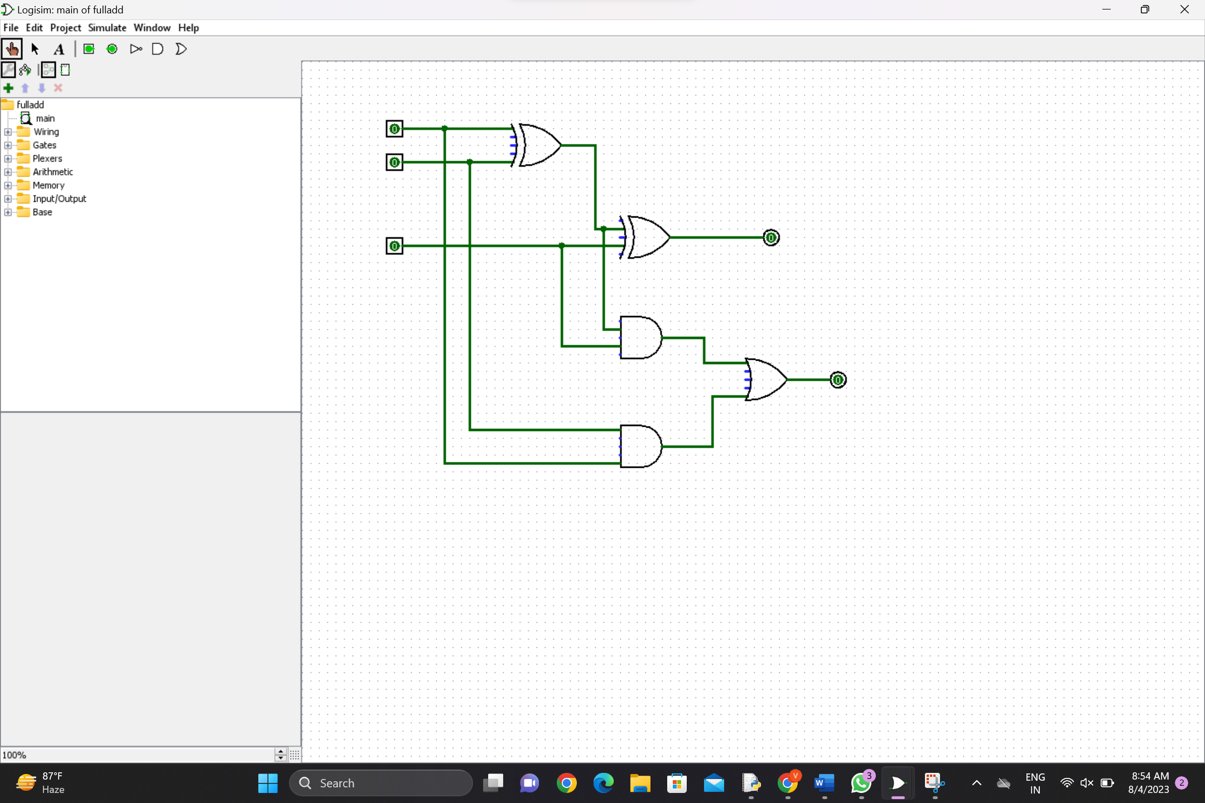

1. PYTHON PROGRAM TO CONVERT DECIMAL TO BINARY

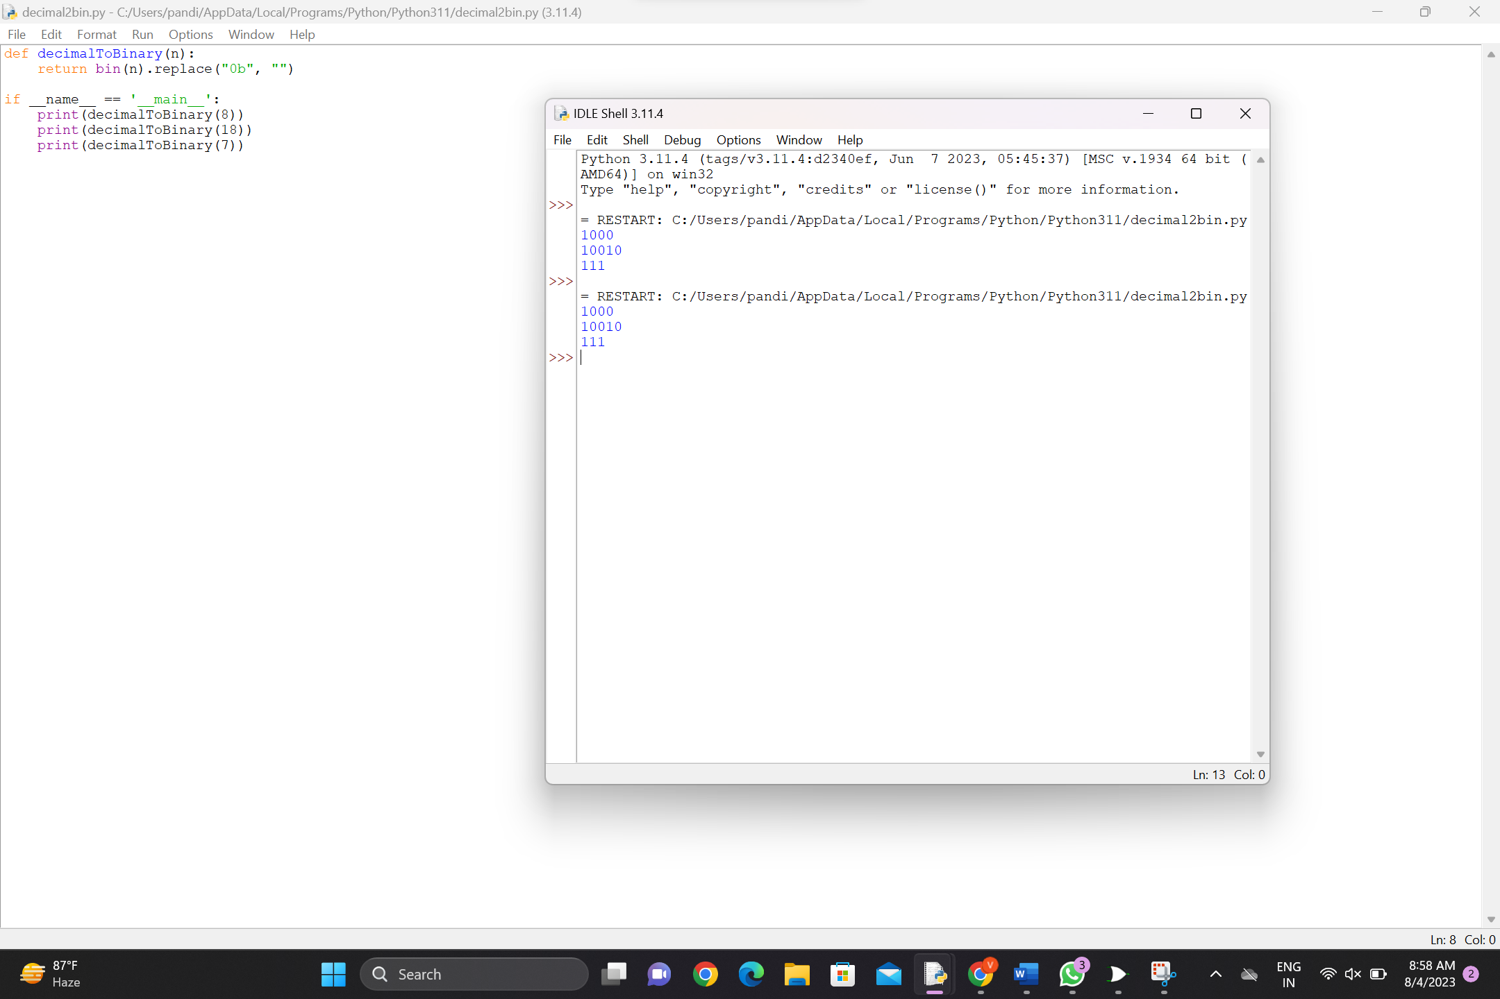

1. PYTHON PROGRAM TO CONVERT BINARY to decimal

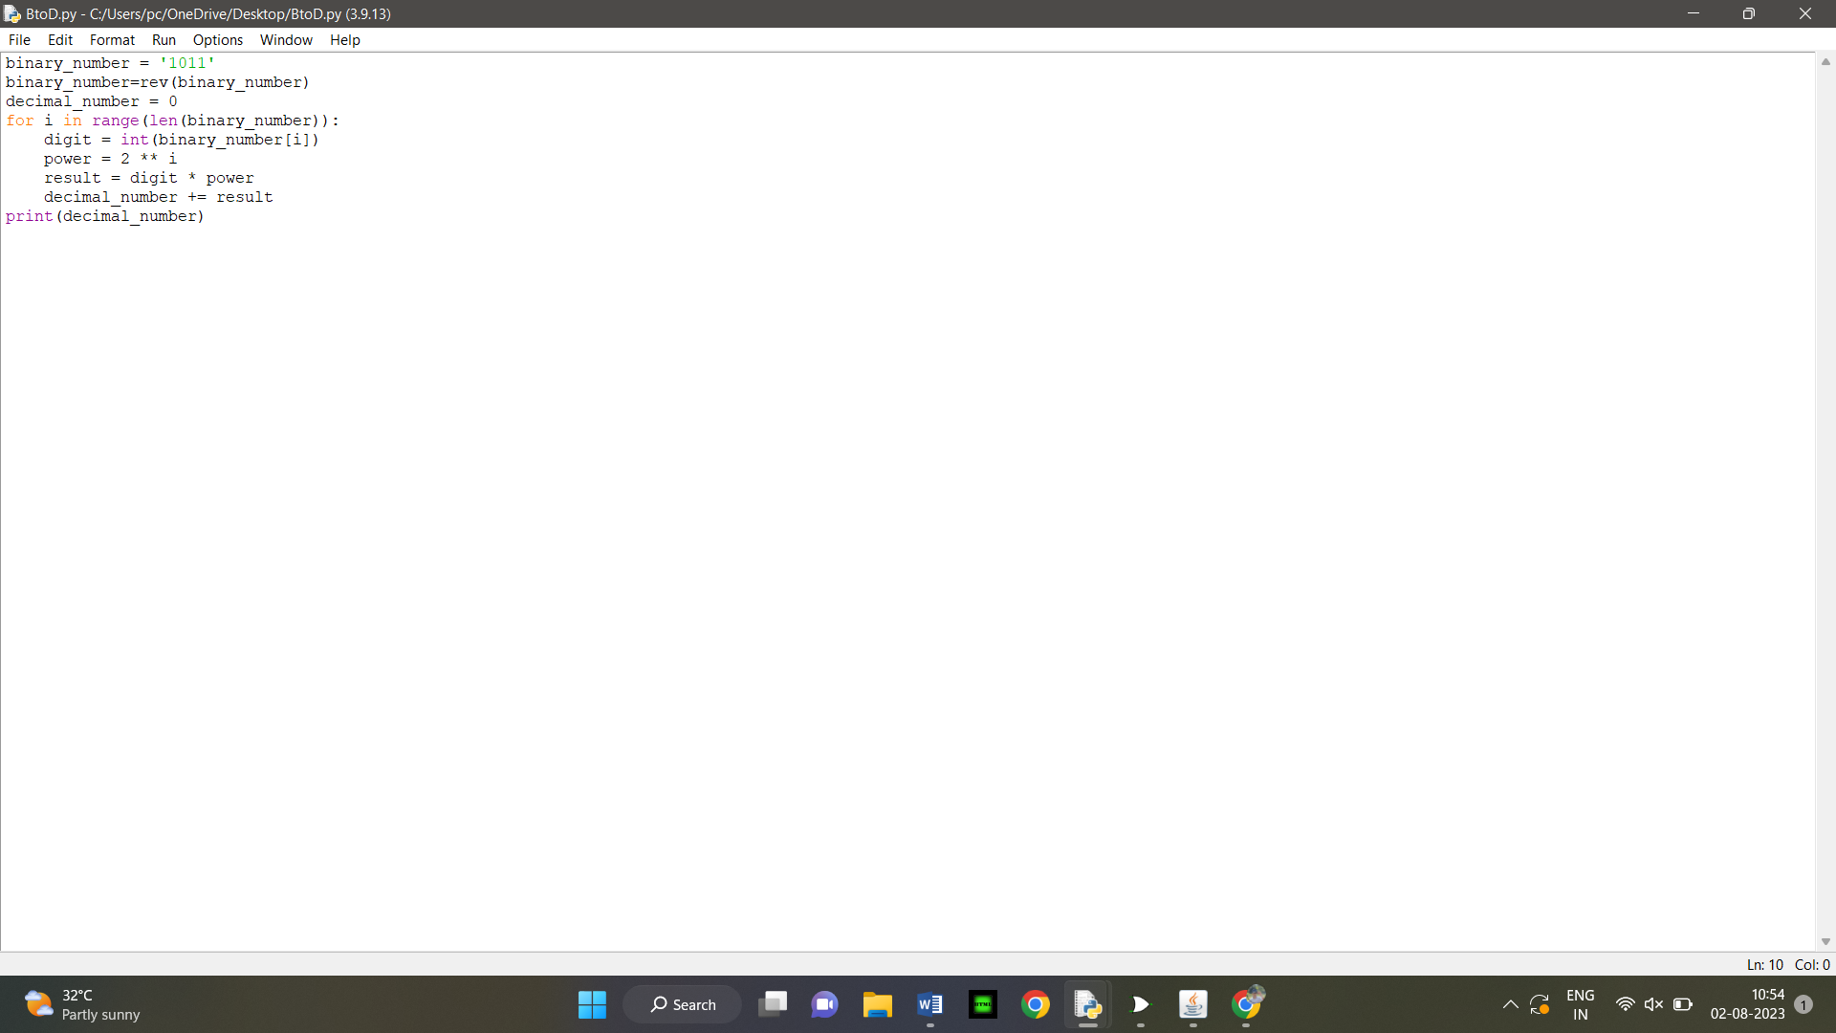

17.PYTHON PROGRAM TO CONVERT DECIMAL TO OCTAL

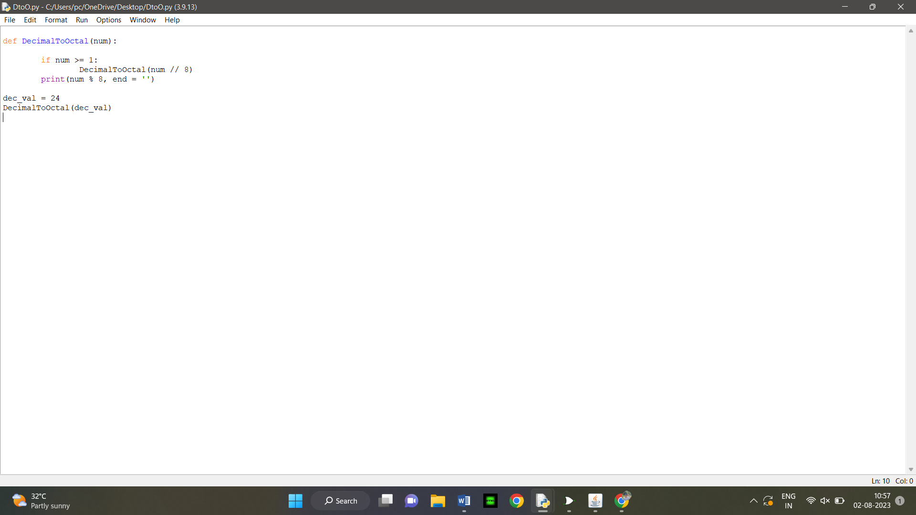18. C PROGRAM TO IMPLEMENT 2 STAGE PIPELINING

